# MongoDB Setups

**Installation Guide :**

* Step 1: Go to Mongo DB Download Center [Link](https://www.mongodb.com/try/download/community)

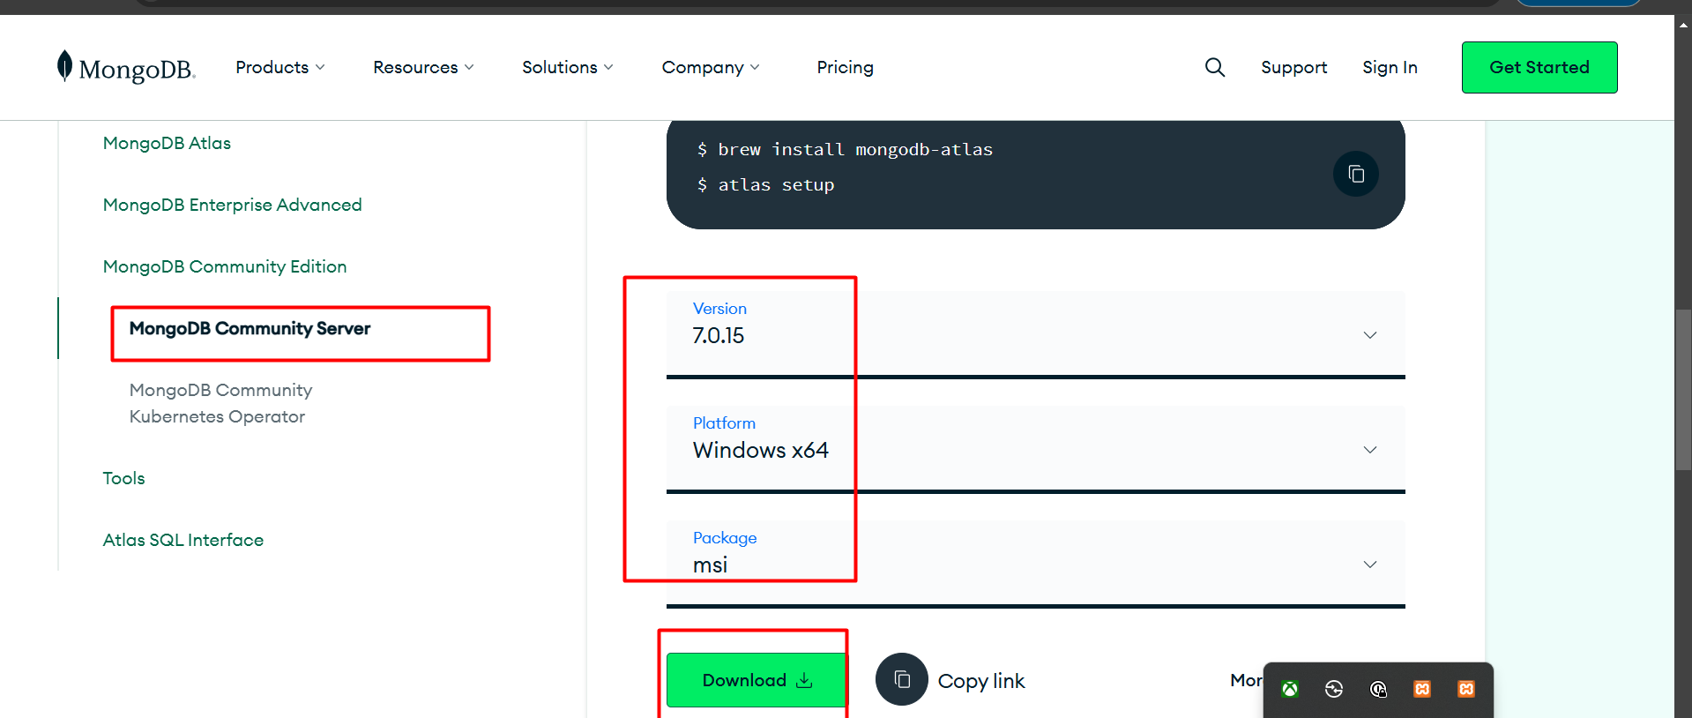

* Version: 7.0.15
* OS: Windows x64
* Package: msi
* Step 2: When the download is complete open the msi file and click the next button

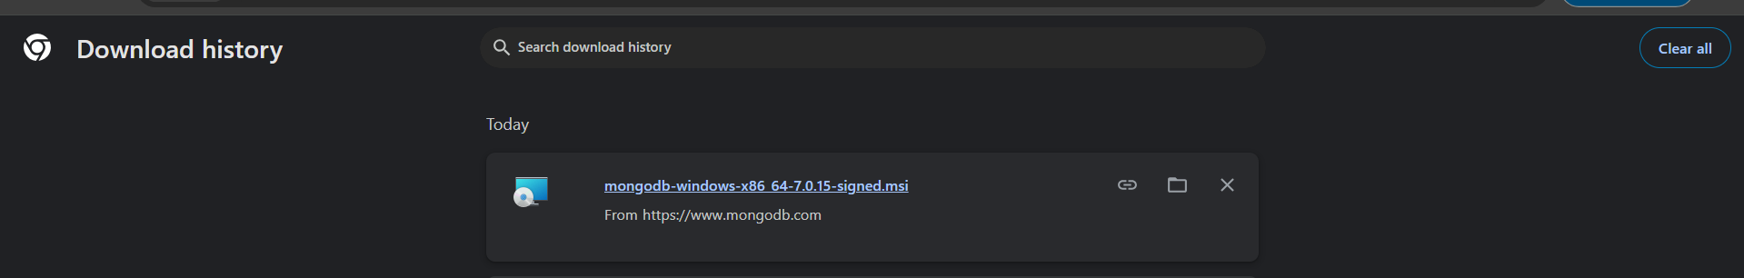

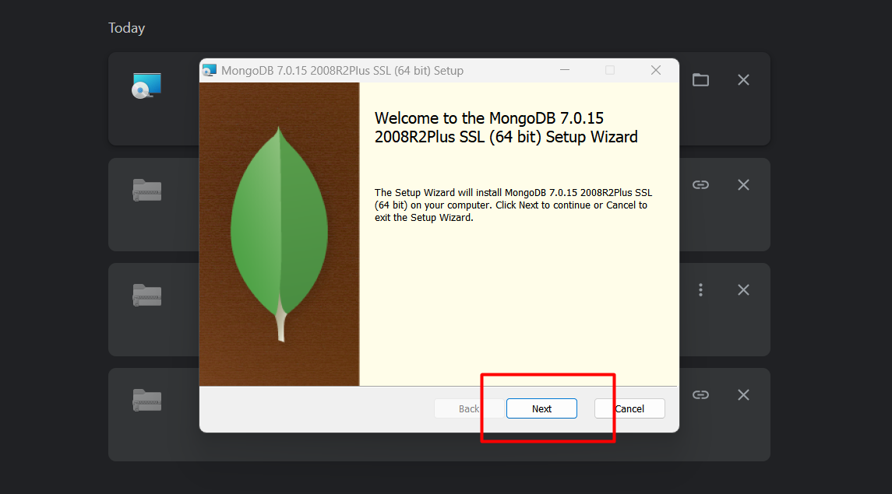

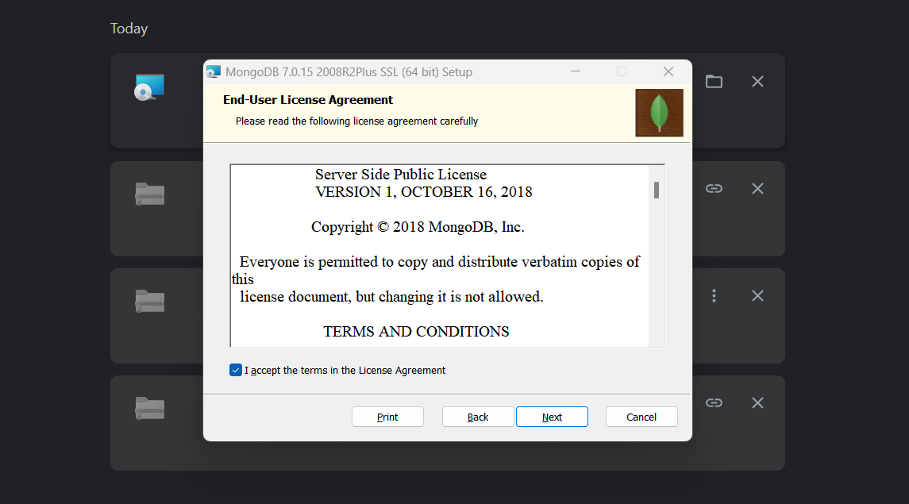

* Step 3: Now select the complete option to install all the program features.

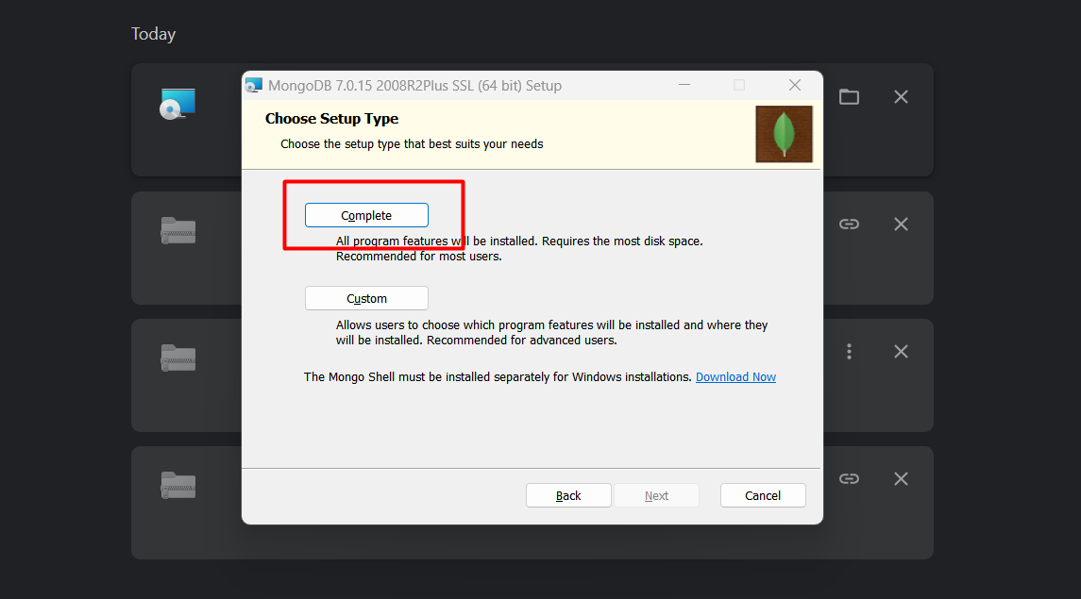

* Step 4: Select “Run service as Network Service user” and copy the path of the data directory. Click Next:

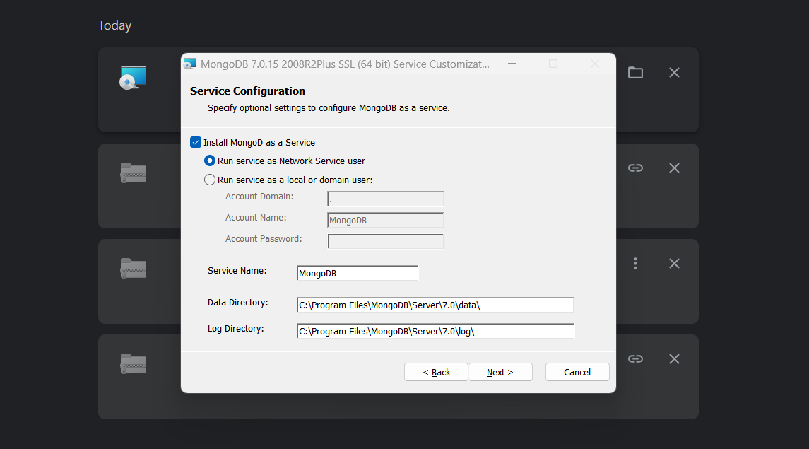

* Step 5: Click the Install button to start the MongoDB installation process:

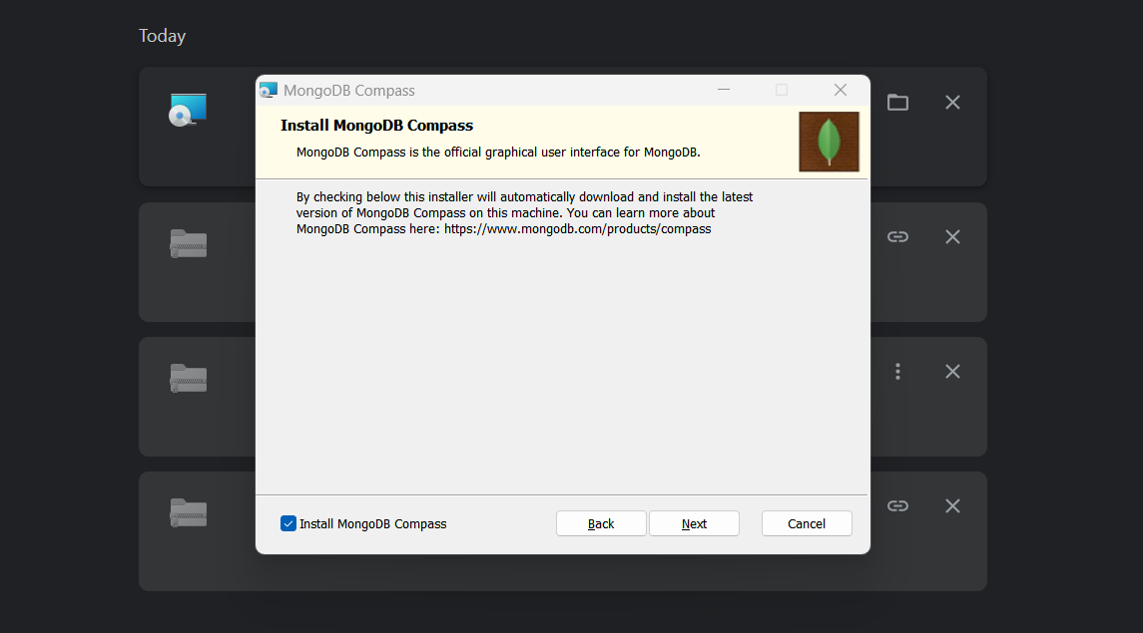

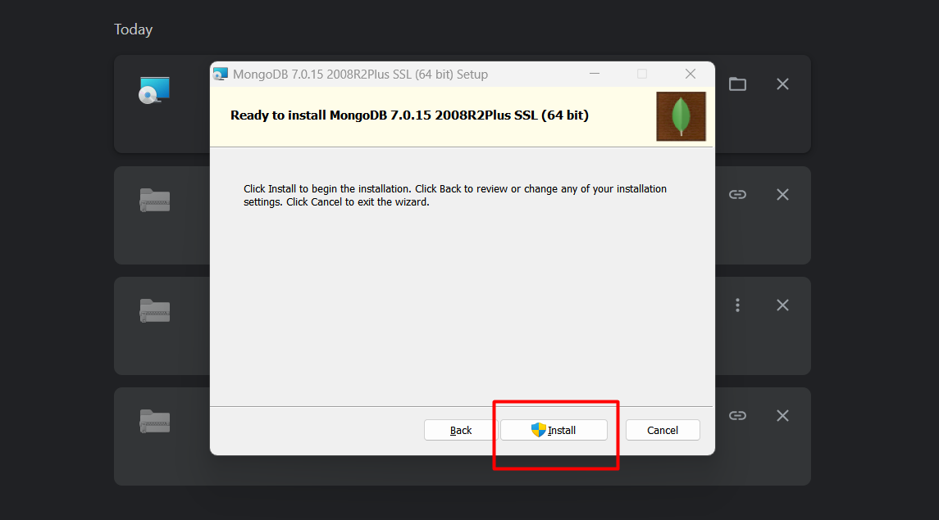

* Step 6: After clicking on the install button installation of MongoDB begins:

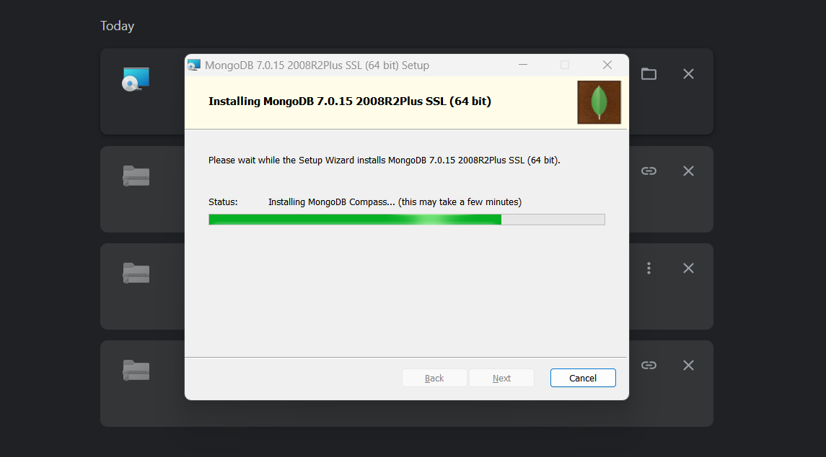

* Step 7: Now click the Finish button to complete the MongoDB installation process:

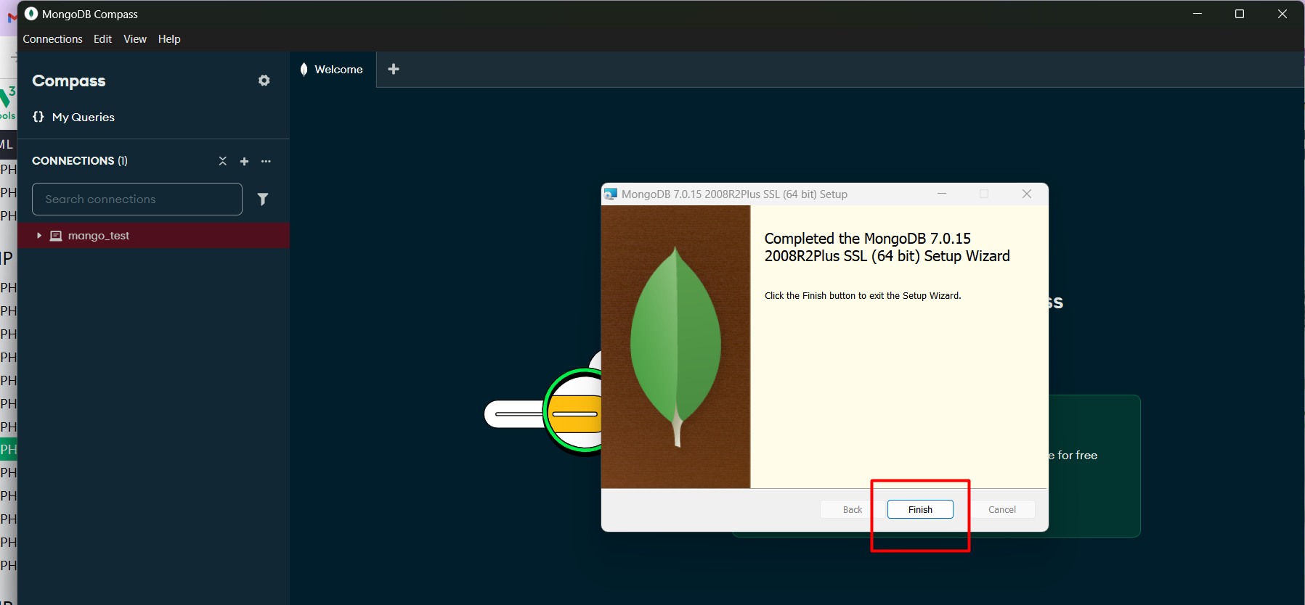

* Step 8: Now we go to the location where MongoDB installed in your system and copy the bin path:

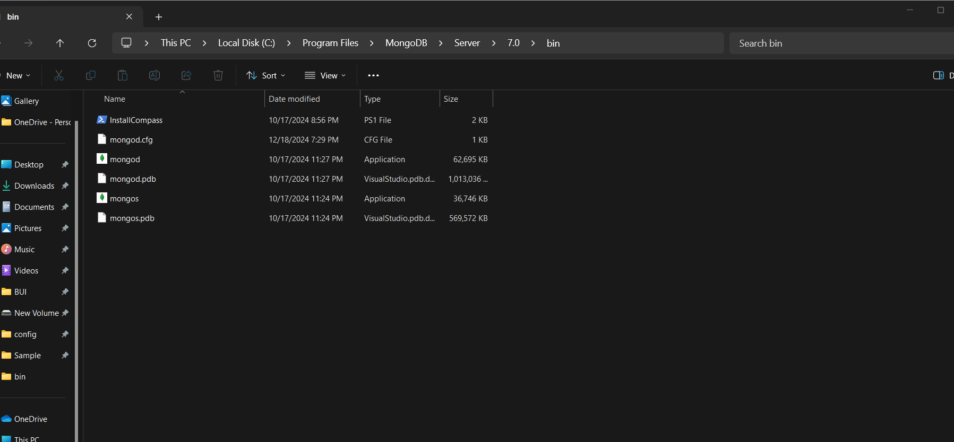

* Step 9: create an environment variable open system properties >> Environment Variable >> System variable >> path >> Edit Environment variable and paste the copied link to your environment system and click Ok:

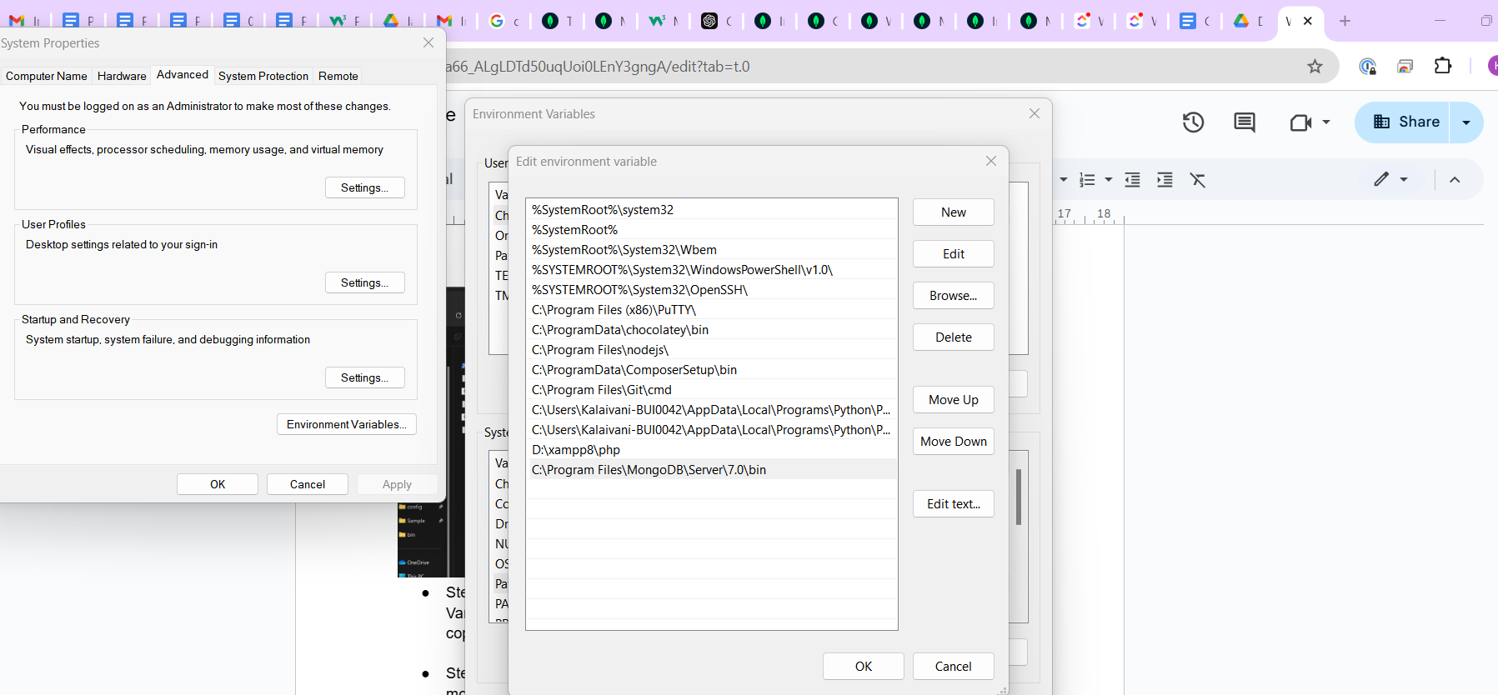

* Step 10: After setting the environment variable, we will run the MongoDB server, i.e. mongod. So, open the command prompt and run the following command:
  + **Mongod**

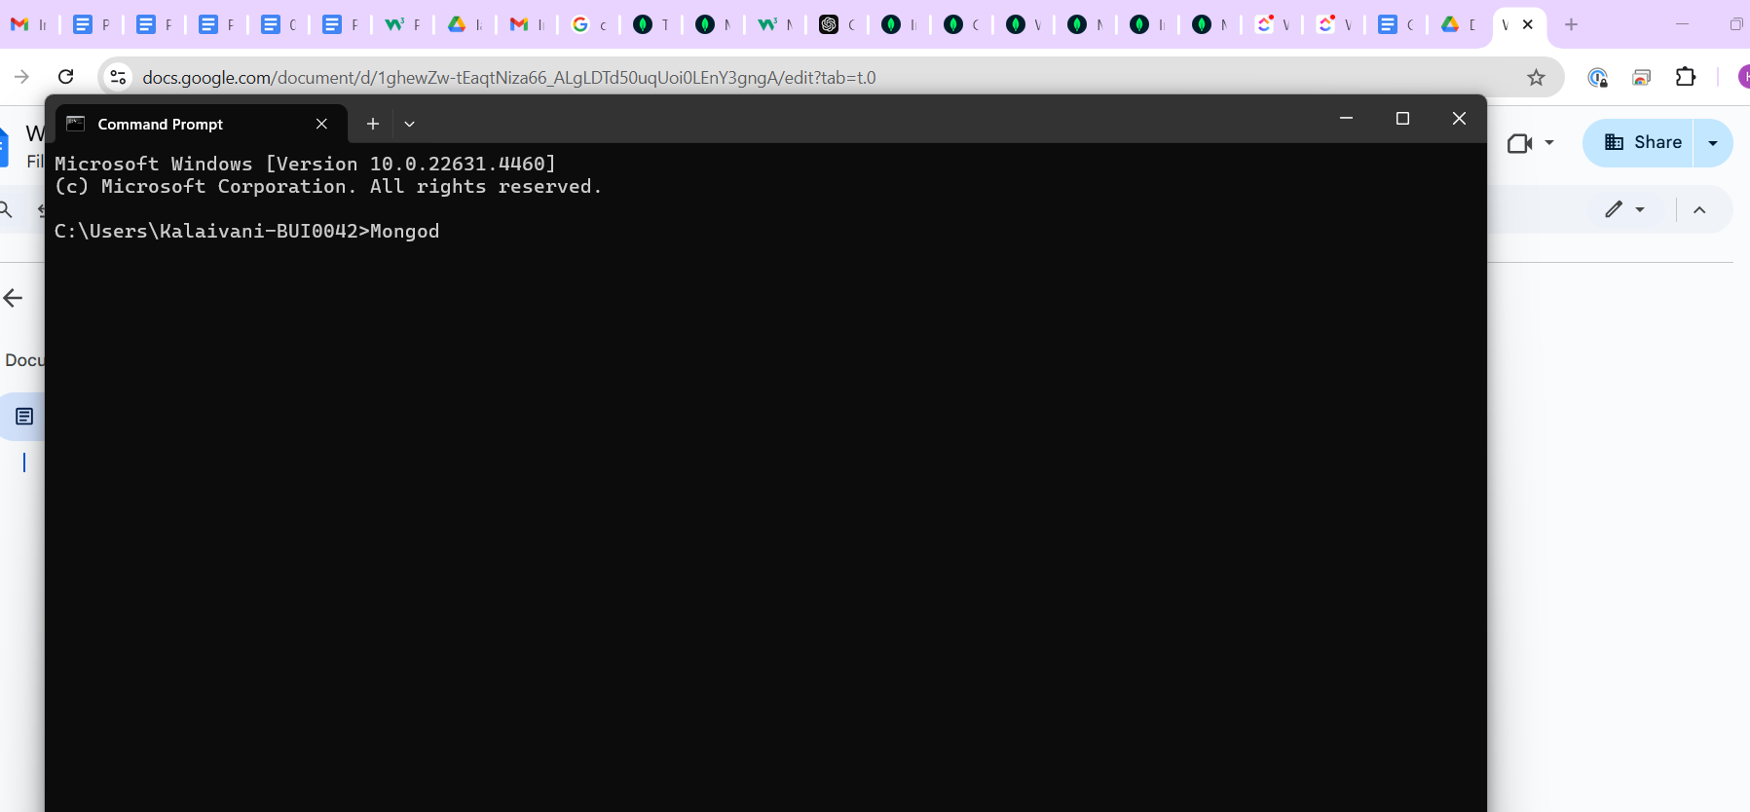

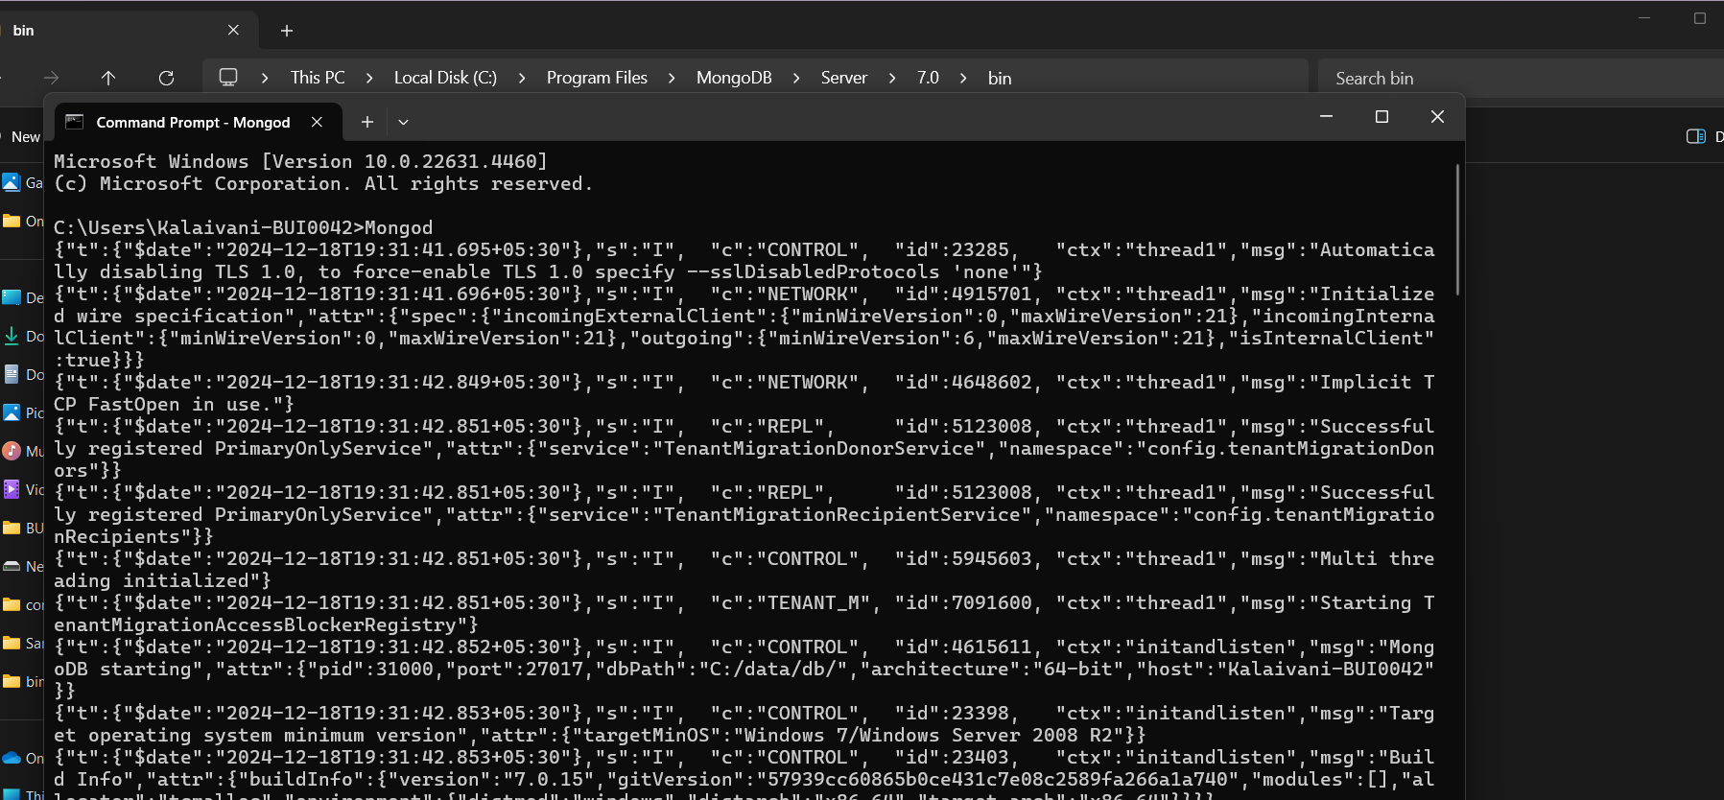

# Mongo DB Compass :

